6 Month Analysis

Tim Vigers & Laura Pyle

08 February 2019

# LMM  
lmer(hba1c ~ tpoint + (1 | record_id),data = alldata,REML = F)

## Linear mixed model fit by maximum likelihood ['lmerMod']  
## Formula: hba1c ~ tpoint + (1 | record_id)  
## Data: alldata  
## AIC BIC logLik deviance df.resid   
## 920.4737 942.4096 -454.2368 908.4737 280   
## Random effects:  
## Groups Name Std.Dev.  
## record_id (Intercept) 1.5244   
## Residual 0.7566   
## Number of obs: 286, groups: record_id, 104  
## Fixed Effects:  
## (Intercept) tpointM1 tpointT1 tpointT2   
## 8.9059 -0.5054 -0.3993 -0.1529

lmer(hba1c ~ days + (1 | record_id),data = alldata,REML = F)

## Linear mixed model fit by maximum likelihood ['lmerMod']  
## Formula: hba1c ~ days + (1 | record_id)  
## Data: alldata  
## AIC BIC logLik deviance df.resid   
## 764.0201 777.9759 -378.0101 756.0201 238   
## Random effects:  
## Groups Name Std.Dev.  
## record_id (Intercept) 1.5036   
## Residual 0.7212   
## Number of obs: 242, groups: record_id, 92  
## Fixed Effects:  
## (Intercept) days   
## 8.6035102 -0.0004797

# Lattice plots  
xyplot(hba1c ~ tpoint + (1 | record_id),alldata)

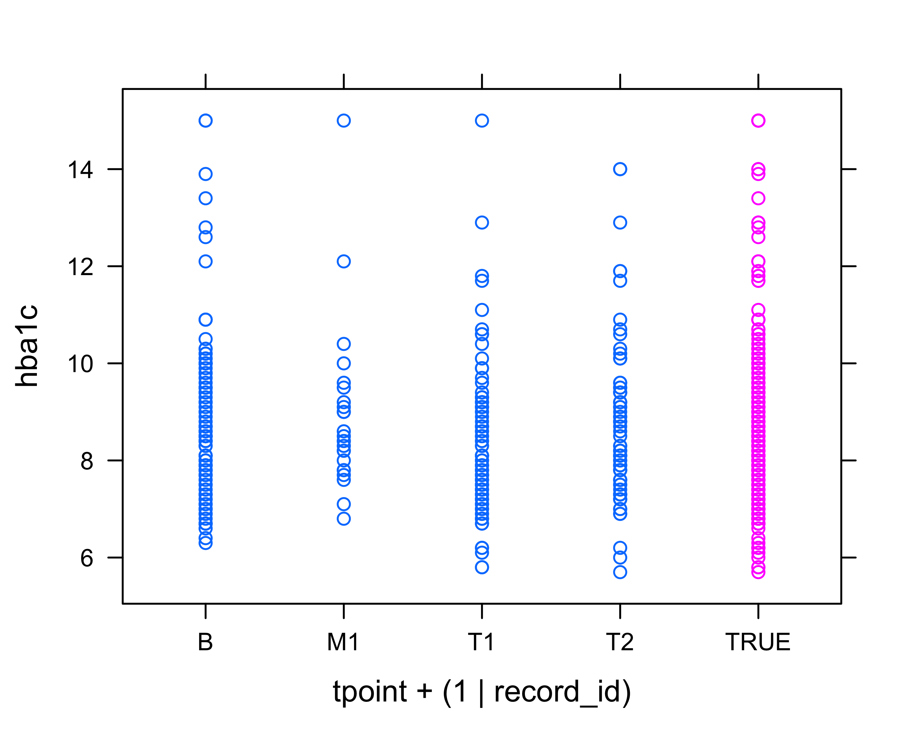

xyplot(hba1c ~ days + (1 | record_id),alldata)

